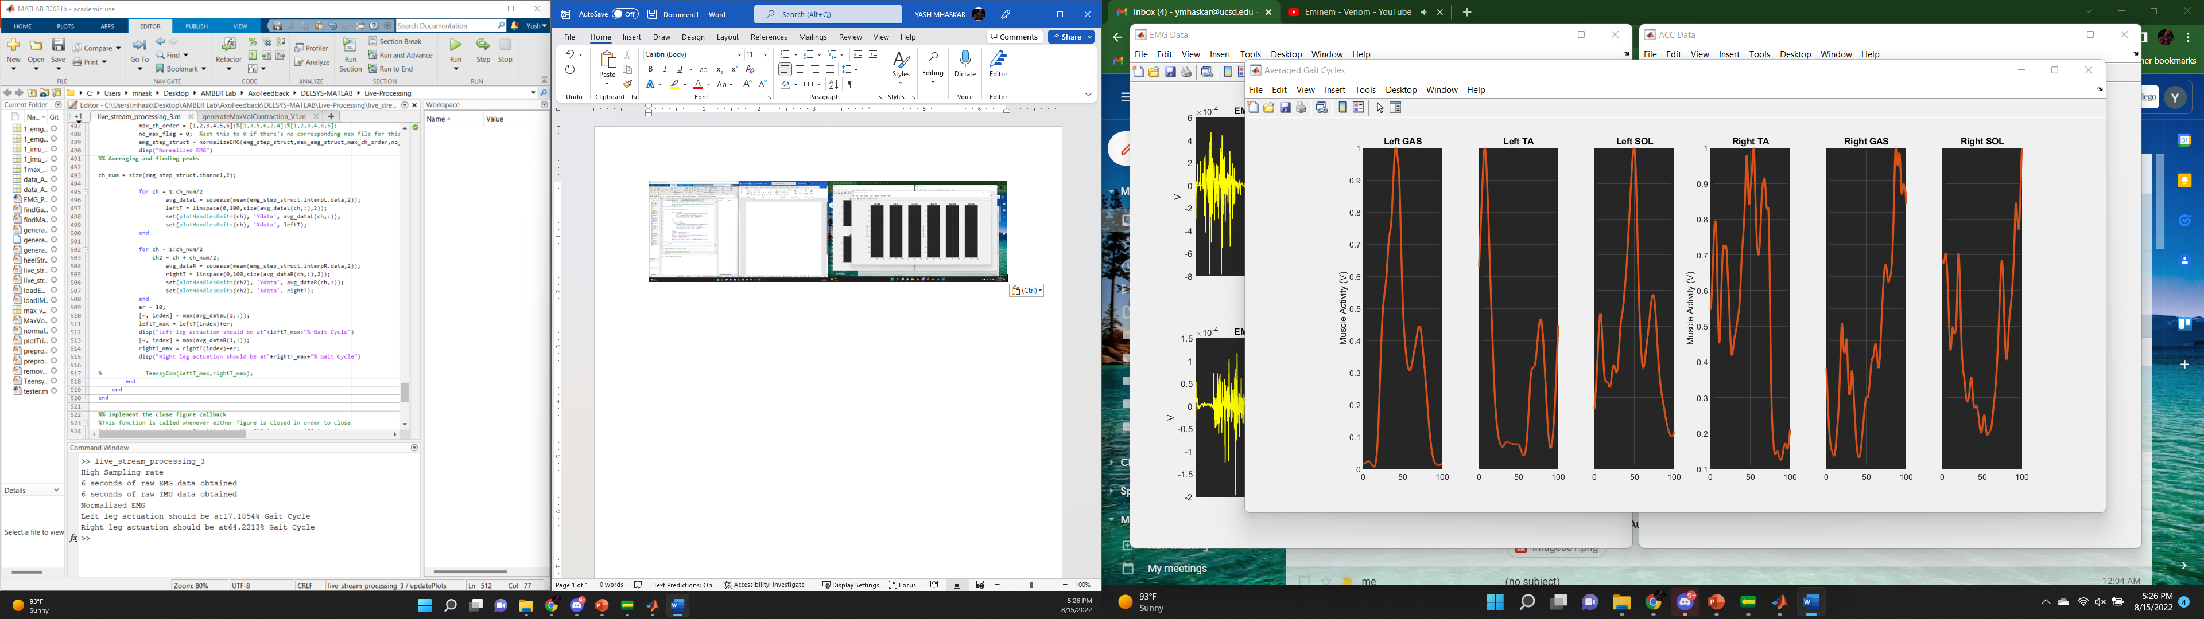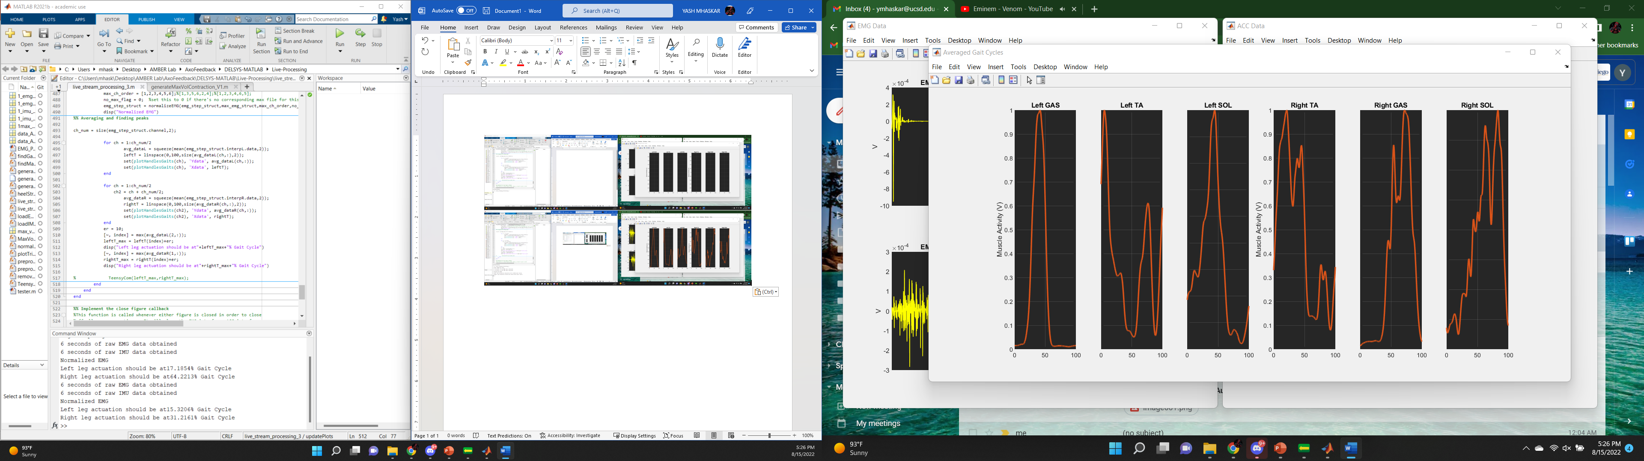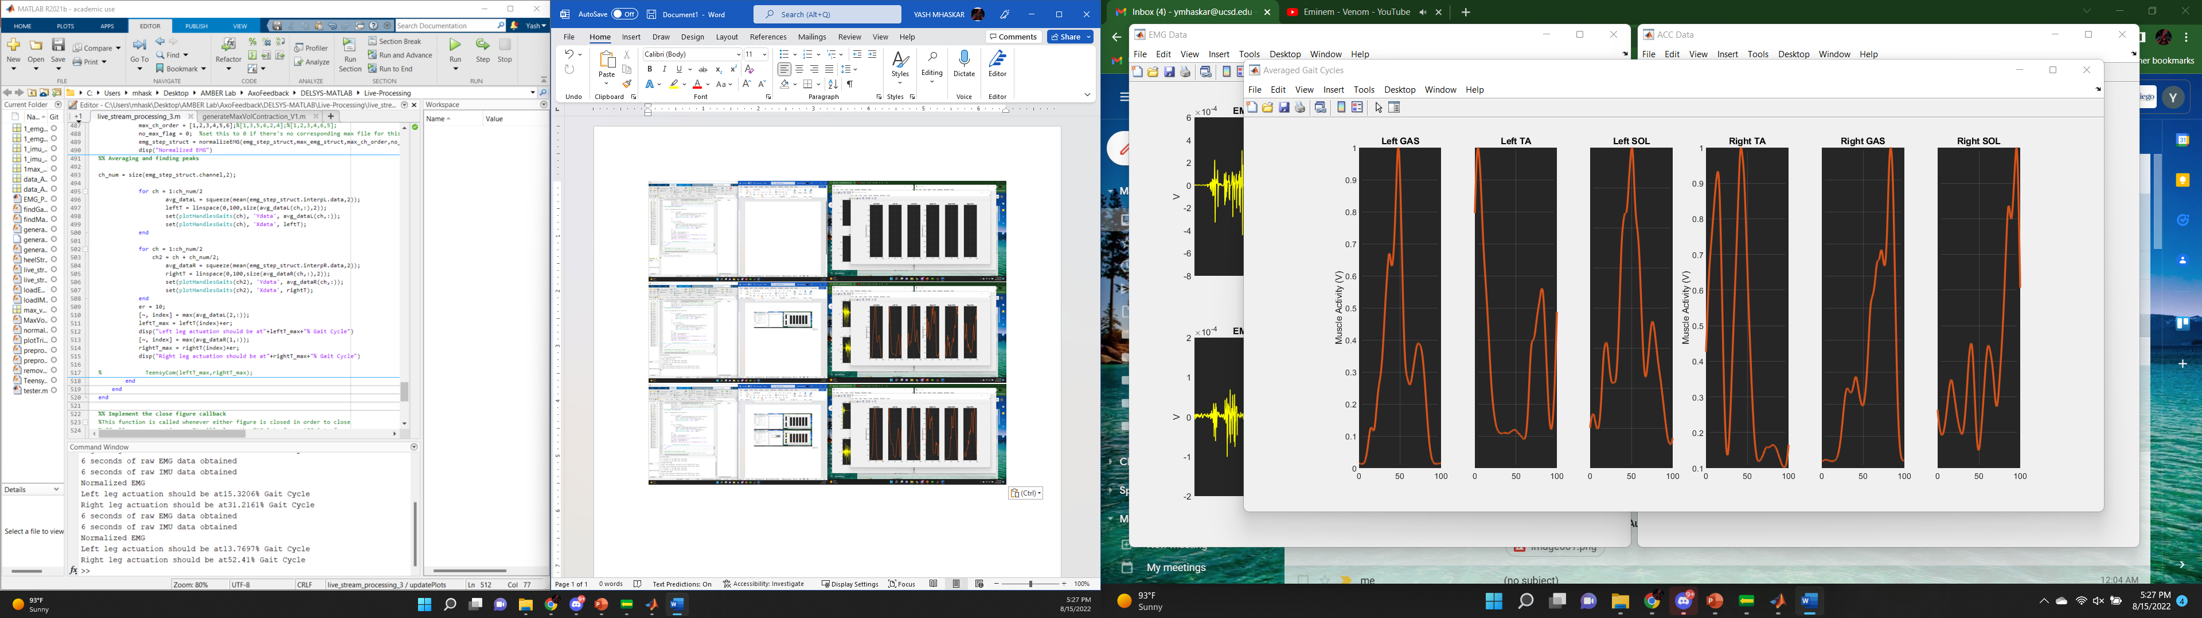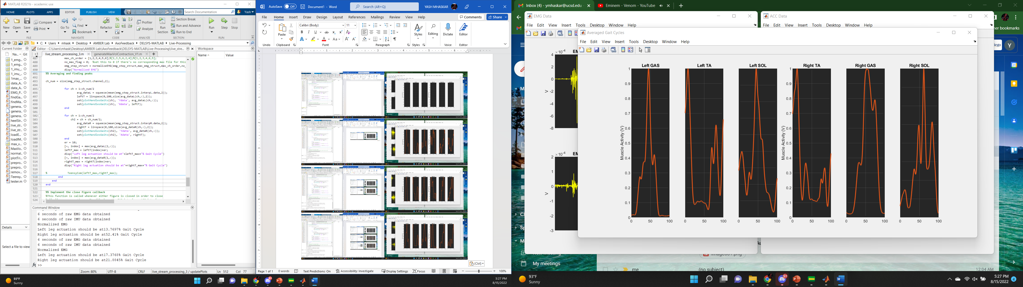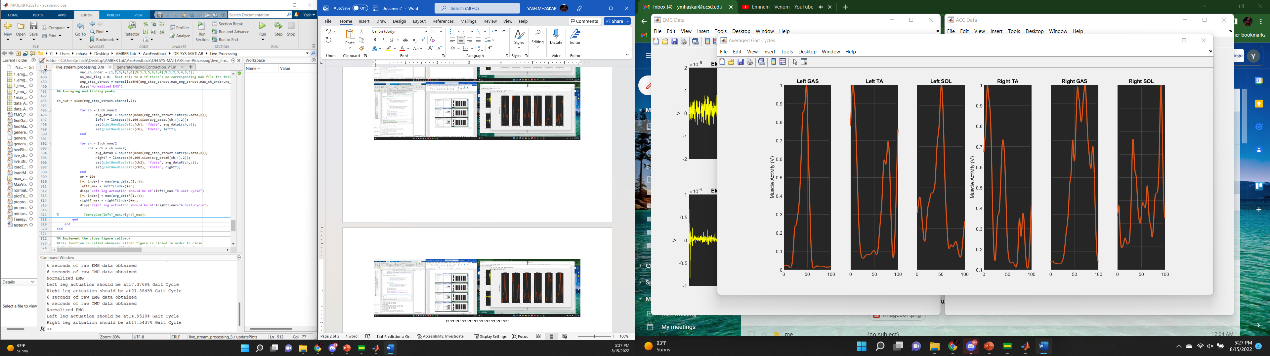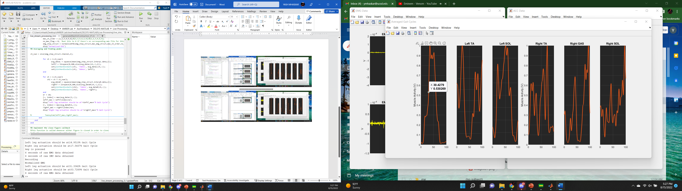

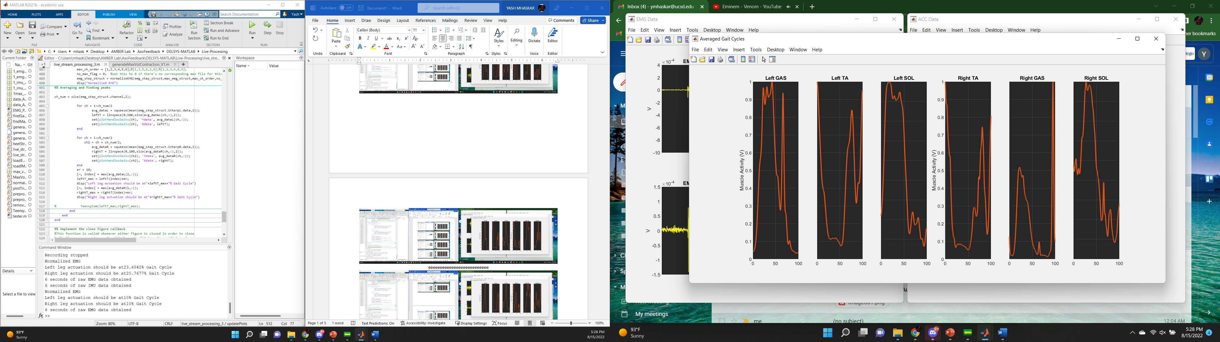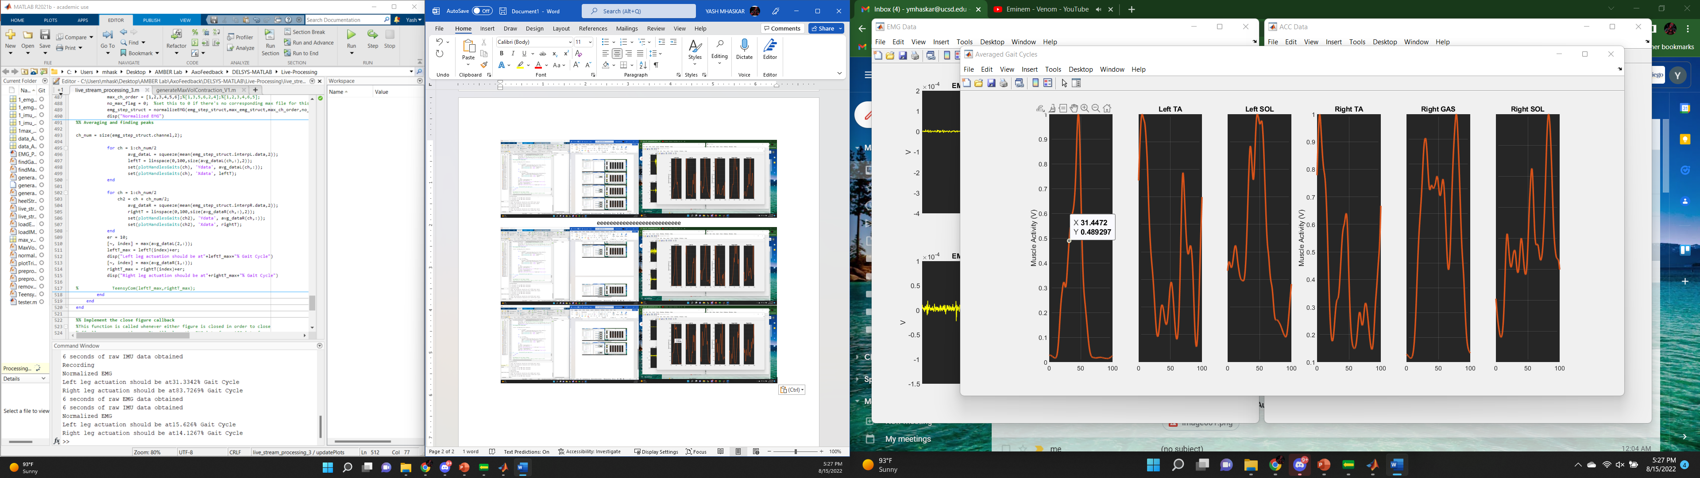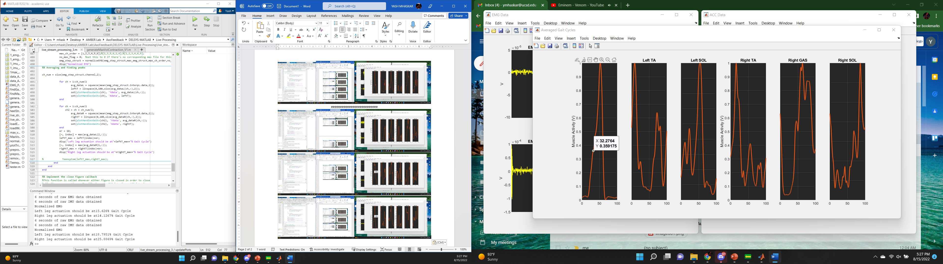

>> live_stream_processing_3

High Sampling rate

6 seconds of raw EMG data obtained

6 seconds of raw IMU data obtained

Normalized EMG

Left leg actuation should be at17.1854% Gait Cycle

Right leg actuation should be at64.2213% Gait Cycle

6 seconds of raw EMG data obtained

6 seconds of raw IMU data obtained

Normalized EMG

Left leg actuation should be at15.3206% Gait Cycle

Right leg actuation should be at31.2161% Gait Cycle

6 seconds of raw EMG data obtained

6 seconds of raw IMU data obtained

Normalized EMG

Left leg actuation should be at13.7697% Gait Cycle

Right leg actuation should be at52.41% Gait Cycle

6 seconds of raw EMG data obtained

6 seconds of raw IMU data obtained

Normalized EMG

Left leg actuation should be at17.3768% Gait Cycle

Right leg actuation should be at21.8845% Gait Cycle

6 seconds of raw EMG data obtained

6 seconds of raw IMU data obtained

Normalized EMG

Left leg actuation should be at14.9518% Gait Cycle

Right leg actuation should be at17.5437% Gait Cycle

key is pressed

6 seconds of raw EMG data obtained

6 seconds of raw IMU data obtained

Recording

Normalized EMG

Left leg actuation should be at31.3342% Gait Cycle

Right leg actuation should be at83.7269% Gait Cycle

6 seconds of raw EMG data obtained

6 seconds of raw IMU data obtained

Normalized EMG

Left leg actuation should be at15.626% Gait Cycle

Right leg actuation should be at14.1267% Gait Cycle

6 seconds of raw EMG data obtained

6 seconds of raw IMU data obtained

Normalized EMG

Left leg actuation should be at18.7951% Gait Cycle

Right leg actuation should be at25.8869% Gait Cycle

key is pressed

6 seconds of raw EMG data obtained

6 seconds of raw IMU data obtained

Recording stopped

Normalized EMG

Left leg actuation should be at23.6842% Gait Cycle

Right leg actuation should be at20.7677% Gait Cycle

6 seconds of raw EMG data obtained

6 seconds of raw IMU data obtained

Normalized EMG

Left leg actuation should be at10% Gait Cycle

Right leg actuation should be at10% Gait Cycle

6 seconds of raw EMG data obtained

6 seconds of raw IMU data obtained

Normalized EMG

Left leg actuation should be at13.929% Gait Cycle

Right leg actuation should be at12.8738% Gait Cycle

6 seconds of raw EMG data obtained

6 seconds of raw IMU data obtained

Normalized EMG

Left leg actuation should be at92.1792% Gait Cycle

Right leg actuation should be at47.1101% Gait Cycle

6 seconds of raw EMG data obtained

>> close all

6 seconds of raw IMU data obtained

Normalized EMG

Left leg actuation should be at64.1874% Gait Cycle

Right leg actuation should be at28.2442% Gait Cycle

>>

